4 **Chapter 4: System Design**

**4.2****Architectural design**

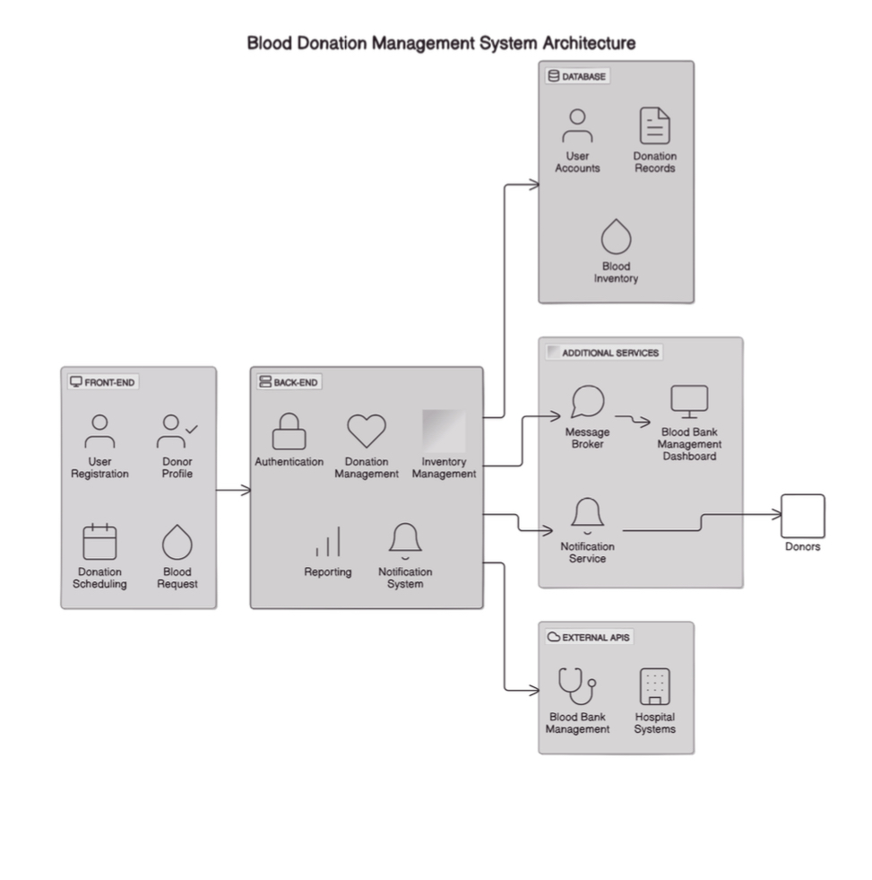

**4.3****Object Oriented Design**

4.3.1 **Class Diagram**

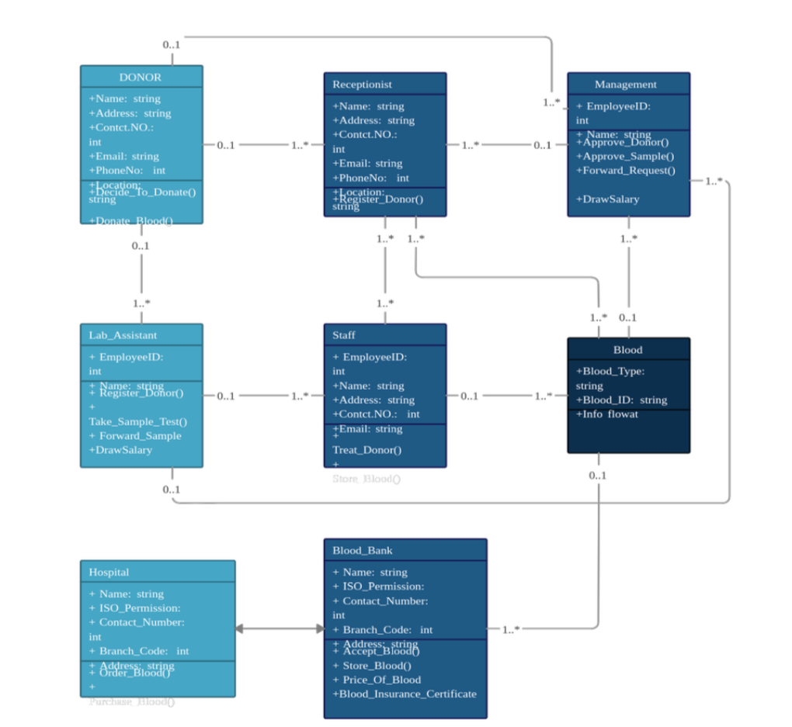

4.3.3 **Activity Diagram**

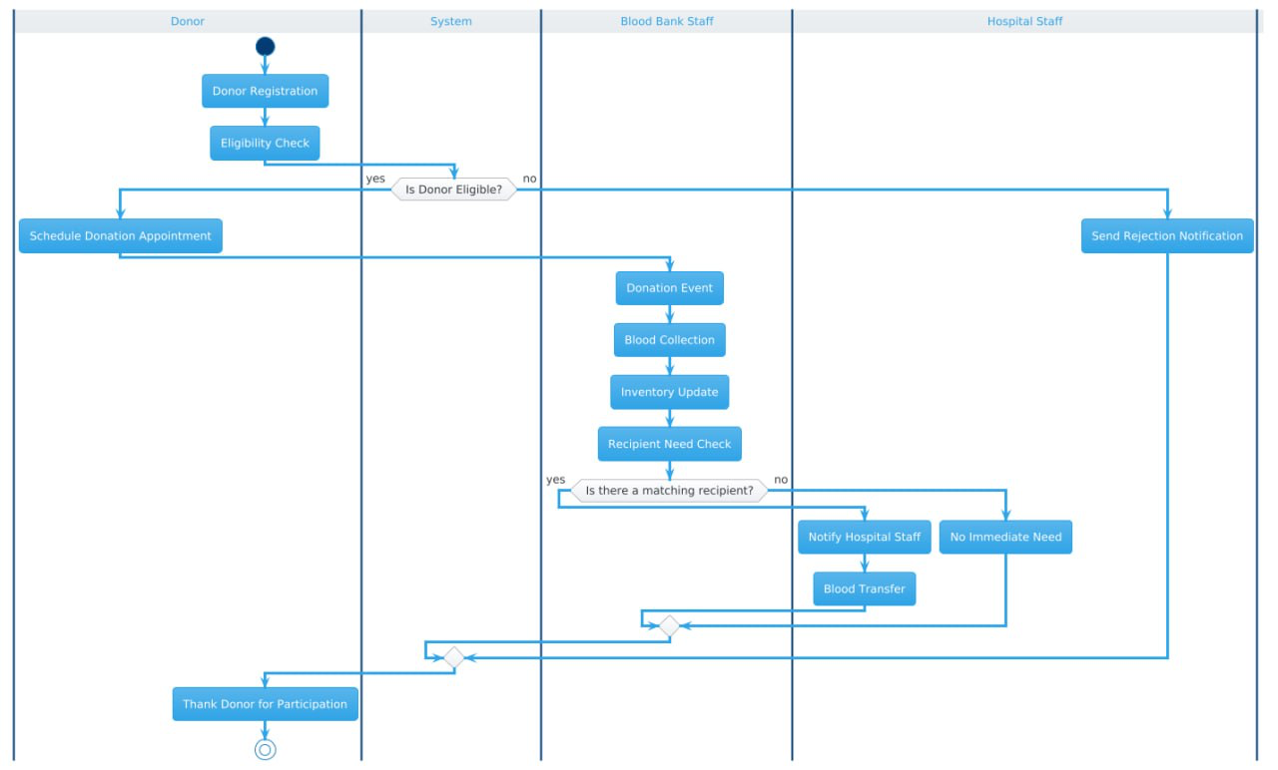

## 

## Database Design

This section focuses on the design of the system's database, including the creation of entity-relationship diagrams (ERDs) and schema definitions. **Table: DONOR**

|  |  |  |
| --- | --- | --- |
| Attribute | Type | Role |
| DonorID | **number** | **PK** |
| Name | **varchar** |  |
| Address | **varchar** |  |
| Contact_NO | **varchar** |  |
| Email | **varchar** |  |
| Reg_Date | **date** |  |
| Blood_Group | **varchar** | **FK** |

**Table: RECIPIENT**

|  |  |  |
| --- | --- | --- |
| Attribute | Type | Role |
| RecipientID | **number** | **PK** |
| Name | **varchar** |  |
| Address | **varchar** |  |
| Contact_NO | **varchar** |  |
| Email | **varchar** |  |
| Phone_NO | **varchar** |  |
| Reg_Date | **date** |  |
| Blood_ID | **number** | **FK** |

**Table: MANAGEMENT**

|  |  |  |
| --- | --- | --- |
| Attribute | Type | Role |
| EmployeeID | **number** | **PK** |
| Name | **varchar** |  |
| Approve_Sample | **boolean** |  |
| Forward_Request | **boolean** |  |
| DrawSalary | **decimal** |  |

**Table: LAB_ASSISTANT**

|  |  |  |
| --- | --- | --- |
| Attribute | Type | Role |
| EmployeeID | **number** | **PK** |
| Name | **varchar** |  |
| Forward_Sample | **boolean** |  |
| DrawSalary | **decimal** |  |
| Blood_ID | **number** | **FK** |

**Table: STAFF**

|  |  |  |
| --- | --- | --- |
| Attribute | Type | Role |
| EmployeeID | **number** | **PK** |
| Name | **varchar** |  |
| Contact_NO | **varchar** |  |
| Email | **varchar** |  |
| Treat_Donor | **boolean** |  |
| DonorID | **number** | **FK** |

**Table: BLOOD**

|  |  |  |
| --- | --- | --- |
| Attribute | Type | Role |
| Blood_ID | **number** | **PK** |
| Blood_Type | **varchar** |  |
| Expiry_Date | **date** |  |

**Table: BLOOD_BANK**

|  |  |  |
| --- | --- | --- |
| Attribute | Type | Role |
| BankID | **number** | **PK** |
| Name | **varchar** |  |
| ISO_Permission | **number** |  |
| Contact_Number | **varchar** |  |
| Address | **varchar** |  |
| Reg_Date | **date** |  |
| Stock | **number** |  |
| Issue_Blood | **boolean** |  |
| Blood_Insurance_Certificate | **boolean** |  |

**Table: HOSPITAL**

|  |  |  |
| --- | --- | --- |
| Attribute | Type | Role |
| HospitalID | **number** | **PK** |
| Name | **varchar** |  |
| ISO_Permission | **number** |  |
| Contact_NO | **varchar** |  |
| Blood_Cluster | **number** |  |